ROSE CARE
Planting
Plant roses in a sunny, well-drained location using rich, amended soil. A site that is somewhat wind protected is preferred. Plant grafted roses with the graft at or below the soil surface. Apply a 3-4” layer of mulch over soil surface to conserve moisture and moderate soil temperatures. Do not let mulch touch base of plant.
Watering
Water regularly, 2-3 times per week. The soil should be kept slightly moist; avoid drying it out too much or keeping it too soggy. Roses will not tolerate ‘wet feet’.
Fertilizing
Fertilize by adding compost to surface of soil in spring (below mulch). Do not till too deep as to disturb roots. Add liquid or granular rose food with a high Phosphorus ratio. Fertilize in May, June, and July, but never after July 30th.
Deadheading
Deadhead spent blooms regularly, cutting back to a full 5-leaf set, leaving an outward facing bud at the top. Stop deadheading and encouraging new growth around September 15th.
Winterizing
Mulch tender roses deeply in late fall to prevent excessive dieback. 8-12” of bark mulch that is not too chunky works fine. Mulch will need to be carefully removed in spring before too much new growth has appeared. Water once per month in winter if there is no snow cover.
Pruning
The goal of rose pruning is to remove diseased or damaged wood, increase air circulation, and shape the plant to encourage growth on flowering wood. Keeping up on pruning produces a healthy, abundantly flowering plant for years to come. Prune roses in spring, just before buds break dormancy and begin to swell. Each rose has pruning needs unique to its variety. See reverse side for detailed pruning guide.
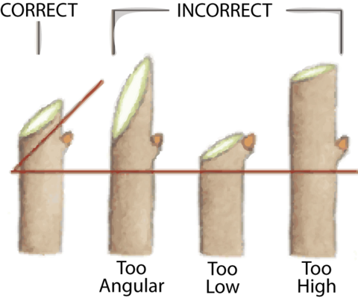
Technique
Cut canes at a 45º angle slightly above chosen bud. Choose a bud facing away from the center of the plant to encourage growth to expand outwards and increase air circulation. Remove weak and spindly growth.

Rose Categories and Pruning Guide
Category |  | Pruning | Example
Modern  (Hybrid Tea, Grandiflora, Floribunda) |  | Maintain 3-6 strong healthy, spaced canes. Cut back fairly hard, removing roughly 2/3 height of canes. Remove from base weak, spindly, or diseased canes. Remove overlapping interior growth to increase air circulation and light. Prune annually. | 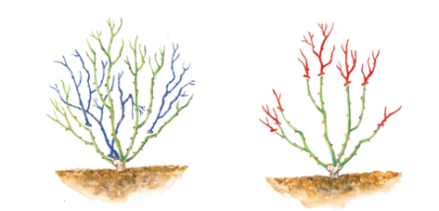
Shrub and English | Single Bloom | Maintain 6-8 strong canes. Prune lightly for first two years. In late summer after flowering, remove 1-2 older, unproductive branches to prevent crowding. | 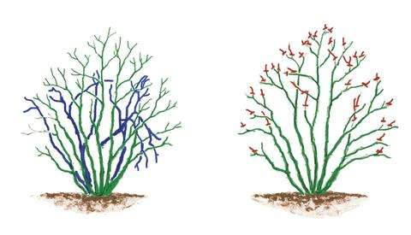
 | Repeat Flowering | Maintain 6-8 strong canes. Prune lightly for first two years. Cut back new growth in late winter by up to 1/3 length. Cut back side shoots to 2-3 buds. Cut back some of the older main stems to the base to encourage growth from base.
Climbing Roses |  | Do not prune for first 2 years, unless removing dead or diseased canes. Prune in dormancy (December-February). Remove dead or diseased branches and cut back flowering side shoots by 2/3 their length. If overgrown or tangled, cut away old branches from the base to promote new growth. | 