Spring Pruning Guide
Talk given by James Feucht Ph.D., Colorado State University Cooperative Extension Landscape Plants Specialist
What to Prune In Spring
Early spring is a good time to prune. Although spring flowering trees and shrubs should be pruned after bloom, other pruning can be done in the early spring.
Avoid top pruning in the spring because many summer-flowering plants form buds on growth produced the previous year. Example of plants that do not do well when top pruned in the spring include lilacs, forsythia, mock-orange, honey suckle and some spirea. Any top pruning will result in loss of flowers.

Pruning to Control Overgrowth
You can thin overgrown shrubs by removing some of the canes. Cutting the undesired stems all the way to the ground will allow light into the middle of the plant and prevent the “leggy” look that can come when shrubs become overgrown.
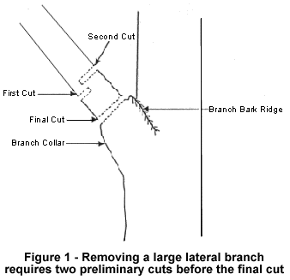
A good rule of thumb is to remove one-third of the oldest canes each year. Remove canes that have become too large, that are insect-or-disease ridden or that may show winter dieback. Pruning these canes leaves a healthy shrub that flowers evenly and does not develop a leggy look.
Pruning Small Trees
Thin small trees at this time, paying particular attention to broken, dead, and diseased branches as well as sucker sprouts and water sprouts that grow vertically in the canopy. Make cuts just outside the flare or branch collar. The collar is the slightly swollen part at the base of the branch.
Avoid top pruning trees or giving the tree a sheared look. When top growth must be removed, make the cut at the crotch of the next branch.
It is important to prune fruit trees each year. This will produce more delicious fruit and encourage a low canopy that is easier to pick from.
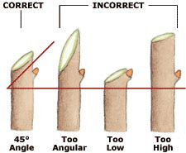
Pruning Shrubs
Pruning summer-flowering shrubs too early may cause growth to resume from the plant’s base before the cold weather passes. Late April or early May is the best time to prune these plants.
When pruning roses, begin at the top of the cane and follow them down until you find healthy stems. Make a 45º cut just above the side bud, preferably to a bud that is pointing away from the center of the plant. This will direct growth outward to form a more shapely plant.
Pruning Equipment
Picture | Tool | Uses
 | Hand Pruners or Shears | Shrubs and branches smaller than a pinky finger
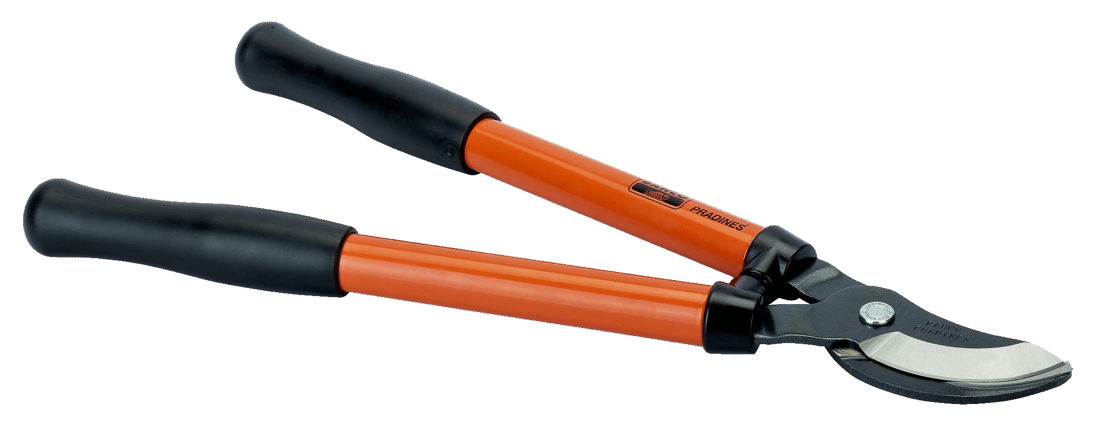 | Bypass Loppers | Branches less than 1” diameter
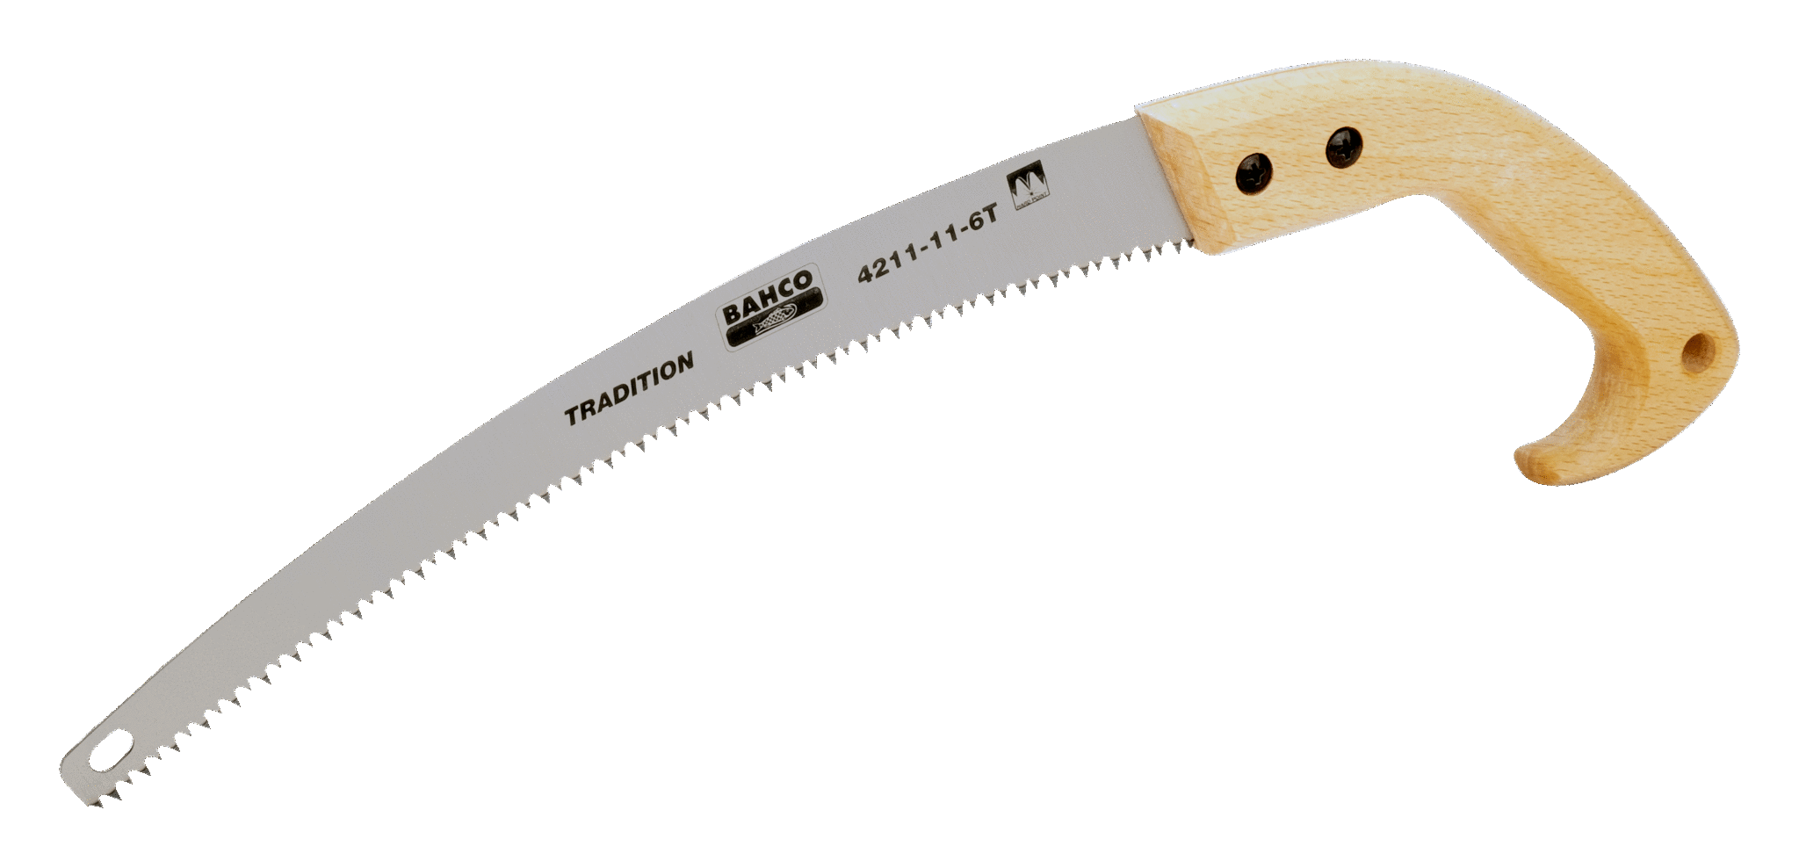 | Pruning Saw | Branches greater than 1” diameter

Tool Care
Clean and Disinfect: Cleaning blades keeps the gunk away and makes for a more efficient tool. Disinfecting prevents disease spread from one tree to another. If trees are bleeding or especially prone to diseases (Aspen), disinfect between each tree.
Sharpen: A sharp blade is a safe blade. Dull tools will mash the section you are pruning, which prevents the wound from healing properly. File the blade in one direction on the cutting edge, and pass once on the backside edge to remove the burrs.

