WATERWISE PERENNIALS

**Moderate Water Needs**

Ajuga reptans – Bugleweed

Alchemilla mollis – Lady’s Mantle

Anemone spp. – Windflower

Aquilegia spp. – Columbine

Bergenia cordifolia

Calamagrostis acu. – Feather Reed Grass

Campanula spp. – Bellflower

Chasmanthium lat. – Northern Sea Oats

Coreopsis spp. – Tickseed

Delphium spp.

Deschampsia caespitosa - Hairgrass

Digitalis spp. – Foxglove

Epilobium spp. – Fireweed

Euonymus fortunei – Wintercreeper

Festuca glauca – Blue Fescus

Gallium ordoratum – Sweet Woodruff

Geranium spp. – Hardy Geranium

Helictotrichon sem. – Blue Oat Grass

Heuchera spp. – Coral Bells

Hosta spp. – Plantain Lily

Iberis sempervirens – Candytuft

Lamium maculatum – Dead Nettle

Leucanthemum s. – Shasta Daisy

Liatris spp. – Gayfeather

Miscanthis sinensis – Maiden Grass

Pennisetum alop. – Fountain Grass

Saponaria spp. – Soapwort

Tanacetum cocc. – Painted Daisy

Tradescantia spp. – Spiderwort

Vinca spp. – Periwinkle

Viola Corsican –Corsican Violet

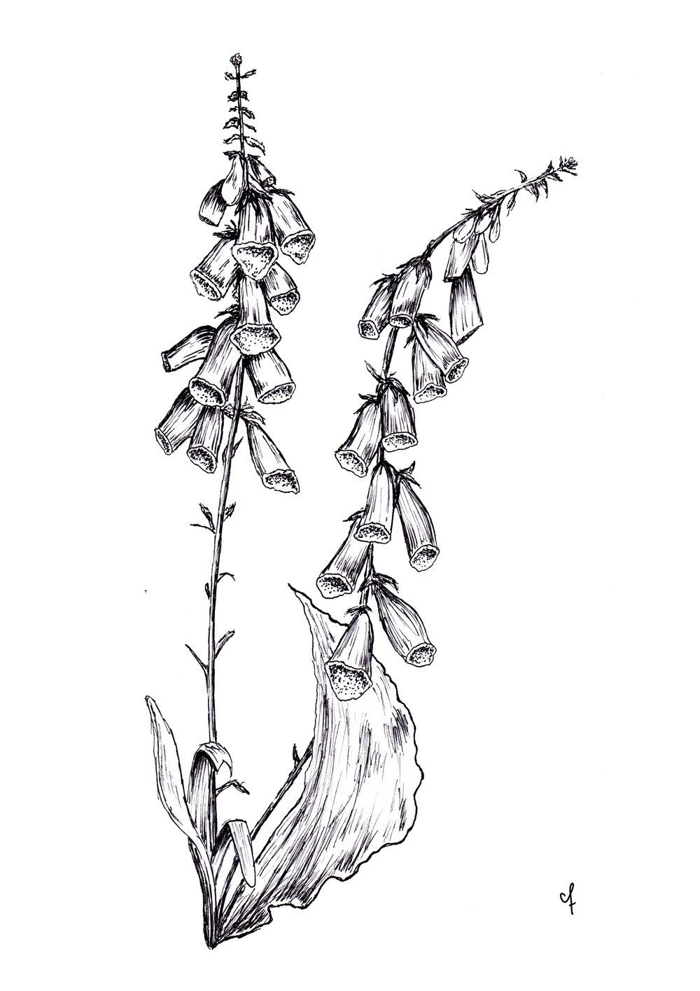

**Low Water Needs**

Achillea spp. – Yarrow

Agastache spp. – Hyssop

Alcea spp. – Hollyhock

Arabis caucasica – Rock Cress

Armeria maritima – Sea Pink

Artemisia spp.

Aster spp.

Aurinia saxatilis – Basket of Gold

Centaurea mon. – Hardy Bachelor Button

Ceratostigma plum. – Plumbago

Chrusanthemum – Garden Mum

Delosperma spp. – Ice Plant

Echinacea purpurea – Purple Coneflower

Erigeron spp. – Fleabane

Gazania spp. – Hardy Gazania

Geum spp.

Gypsophila spp. – Hardy Baby’s Breath

Helianthemum nummularium – Sun Rose

Hemerocallis spp. – Daylily

Iris germanica – Bearded Iris

Kniphofia uvaria – Red Hot Poker

Lavandula

Malva alcea – Rose mallow

Nepeta faas. – Catmint

Osteospermum bar. – Sun Daisy

Paeonia lactiflora – Peony

Papavar spp. – Poppies

Persicaria aff. – Himalayan Border Jewel

Phlox subulate – Creeping Phlox

Polemonium caer. – Jacob’s Ladder

Potentilla spp. – Cinquefoil

Pulsatilla vulgaris – Pasque Flower

Rudbeckia spp. – Black Eyed Susan

Salvia argentea – Silver Sage

Salvia spp. – Hardy Salvia

Santolina spp. – Lavender cotton

**Low Water Needs Continued…**

Scabiosa spp. – Pincushion Flower

Sedum spp. – Stonecrop

Sempervivum spp. – Hen & Chicks

Solidago spp. – Goldenrod

Sorghastrum nutans – Indian Grass

Stachys byzantine – Lamb’s ears

Tanacetum niveum – Snow Daisy

Thymus spp. – Creeping Thyme

Veronica spp. - Speedwell

Lowest Water Needs

Antennaria spp. – Pussytoes

Artemisia frigida – Fringed Sage

Asclepias tub. – Butterfly Weed

Berlandiera l. – Chocolate Flower

Callirhoe invol. – Poppy Mallow

Calylophus serr. – Sundrops

Centranthus r. – Jupiter’s Beard

Dalea purpurea – Prarie Clover

Echinops ritro – Globe Thistle

Eriogonum spp. – Sulphur Flower

Eryngium ame. – Sea Holly

Gaillardia a. – Blanket Flower

Gaura lin. – Whirling Butterflies

Gilia agg. – Scarlet Gilia

Liatris pun. – Dotted Gayfeather

Linum perenne – Blue Flax

Mirabilis mul. – Four O’Clock

Oenothera – Evening Primrose

Panicum virgatum – Switch Grass

Penstemon spp.

Perovskia a. – Russian Sage

Ratibida col. – Prairie Coneflower

Sphaeralcea spp. – Globemallow

Thermopsis m. – Goldenbanner